

Sagility

Assessment Expert24 Proxy Integration


Technical Specification
September 11, 2026

Version Information
Version | Date | Author | Changes
1.0 | 2026.09.11 | Jody McGuire | Initial draft.

Contents
1. Background 4
2. Functional Overview 4
3. Assessment Execution Lifecycle 4
4. E24 Proxy Layer 5
4.1. E24ProxyController API 5
4.1.1. Controller Overview 5
4.1.2. Public Endpoints 6

Background
There exists the need to be able to perform an Expert24 assessment by means other than the existing Assessment Control. This document will describe the Expert24 proxy layer that has been built, providing consuming applications with the ability to instantiate and perform assessments while providing their own UI implementation.
Expert 24 is physically located in England and exposes capabilities to create and execute assessments in the cloud.

Functional Overview
An E24 proxy layer has been developed upon the Clinical Content Service as a new controller and provides the ability to drive the creation and execution of an assessment via API calls.

Assessment Execution Lifecycle
The following image describes the operations that occur when initiating and performing an assessment, with clear delineation of the operations that are provided by the Expert24 cloud-based assessment service.
The Consuming Application would be your Angular application. In it you would embed the Assessment Control and supply it with the required set of input values to successfully instantiate and utilize the control.
The Consuming Application component initializes the Assessment Control with a set of inputs that initialize the control with the metadata needed for it to load the specified assessment.
Once the assessment has been initialized, the user or member interacting with your application will be presented with the first question in the assessment. As the member supplies answers to the individual questions and selects the Next button, the member will be presented with the next question in the assessment until the end of the assessment has been reached.
Once the end of the assessment has been reached a final set of data will be returned that contains the answered questions, any outcome recommendations, and any care plan items.

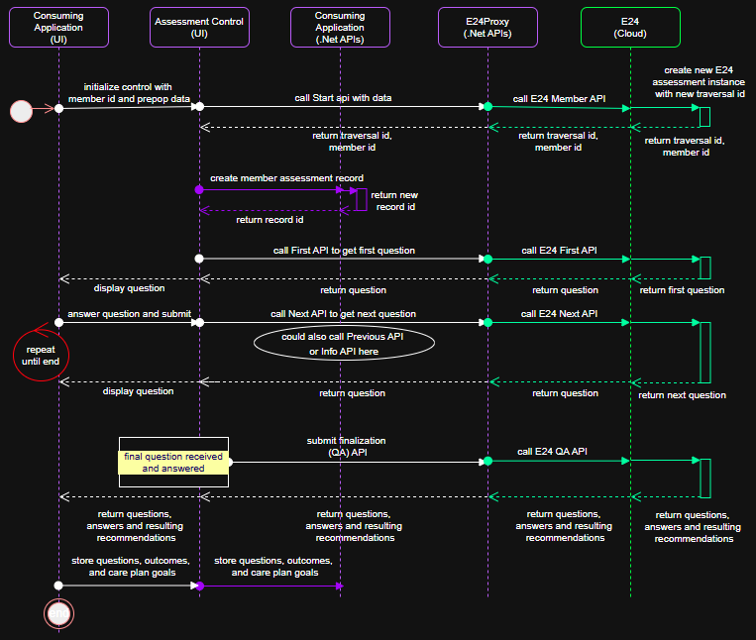

E24 Proxy Layer

E24ProxyController API

Controller Overview
The E24ProxyController implements a communication abstraction between the UI Assessment control and the Expert24 cloud APIs. While it is used by the Assessment control, it also provides the ability for other implementations of assessment delivery to occur, such as providing phone/AI based assessment delivery.

Note: You are highly encouraged to review the accompanying document titled Assessment Control Integration-v3 located within this same SharePoint site as it describes an assessment tester application that can be used to experiment with initiating and executing assessments, allowing you to view example data for calling each of the below APIs.

Product Repo:
Assessment Control: (dev_standalone) /source/Components/ClinicalContent/AssessmentControl
Clinical Content Service: (dev_standalone) /source/Components/ClinicalContent/ContentService

Base route: api/E24Proxy

Purpose: Proxies client requests to Expert24 traversal APIs.

Notes:
- All endpoints require query parameter: expert24urlBase
- Responses preserve upstream status code, response body, and content type.

Project Locations

Product Repo
Assessment Control: (dev_standalone) /source/Components/ClinicalContent/AssessmentControl

Clinical Content Service: (dev_standalone) /source/Components/ClinicalContent/ContentService

Public Endpoints

Start Assessment
Starts an Expert24 assessment as a new assessment.
Method/Route: POST api/E24Proxy/start

Query: expert24urlBase (required)

Body: memberId (string, required), prepop (object, optional) (see Prepop section for details)

Upstream: POST expert24urlBase/webbuilder/TraversalService/Member

Upstream payload:
{
"memberId": "string",
"prepop": [
"string"
]
}

2) Begin-Continue
Sets up an assessment for continuance of an existing incomplete Expert24 assessment.
Method/Route: POST api/E24Proxy/begin-continue/traversalId/e24MemberId

Route params: traversalId (string), e24MemberId (string)

Query: expert24urlBase (required)

Body: memberId (string, required), prepop (object, optional)

Upstream: POST expert24urlBase/webbuilder/TraversalService/Prepop/traversalId/e24MemberId

Upstream payload:
{
"memberId": "string",
"prepop": [
"string"
]
}

3) Continue
Continue an existing incomplete Expert24 assessment.
Method/Route: GET api/E24Proxy/continue/traversalId/e24MemberId

Route params: traversalId (string), e24MemberId (string)

Query: expert24urlBase (required)

Upstream: GET expert24urlBase/webbuilder/TraversalService/GoBack/traversalId/e24MemberId/0/-1

4) First
Get the first question for an assessment.
Method/Route: POST api/E24Proxy/first/traversalId/e24MemberId/algorithmId

Route params: traversalId (string), e24MemberId (string), algorithmId (string)

Query: expert24urlBase (required), language (optional)

Language normalization: spa/spanish -> SPANISH; eng ->English; otherwise MEMBER.

Upstream: POST
expert24urlBase/webbuilder/TraversalService/First/traversalId/e24MemberId/algorithmId/0?Language=MEMBER|SPANISH

5) Next
Get the next question for an assessment.
Method/Route: POST api/E24Proxy/next/traversalId/e24MemberId/algorithmId/previousNodeId

Route params: traversalId (string), e24MemberId (string), algorithmId (string), previousNodeId (int)

Query: expert24urlBase (required)

Body: arbitrary JSON (optional); defaults to

{
"memberId": "string",
"prepop": [
"string"
]
}

Upstream: POST
expert24urlBase/webbuilder/TraversalService/Next/traversalId/e24MemberId/algorithmId/previousNodeId

6) Previous
Get the previous question for an assessment.
Method/Route: GET api/E24Proxy/previous/traversalId

Route param: traversalId (string)

Query: expert24urlBase (required)

Upstream: GET expert24urlBase/webbuilder/TraversalService/Previous/traversalId

7) Info
Get the informational (tooltip) text for a question or answer.
Method/Route: GET api/E24Proxy/info/traversalId/noteType/itemId

Route params: traversalId (string), noteType (int), itemId (int)

Query: expert24urlBase (required)

Upstream: GET expert24urlBase/webbuilder/TraversalService/Info/traversalId/noteType/itemId

8) QA
Get the final set of a data for a completed assessment. It includes the questions and answers as well as any outcome recommendations or care plan items.
Method/Route: GET api/E24Proxy/qa/traversalId

Route param: traversalId (string)

Query: expert24urlBase (required)

Upstream: GET expert24urlBase/webbuilder/TraversalService/QA/traversalId

Consumer Notes
Pass a fully qualified expert24urlBase value, including scheme (for example, https://...).

Use environment-specific base URLs for development, QA, UAT, or production.

API property definitions
memberId - The id of the member for which the assessment will be performed. The value specified must exist in the Web Service URL identified target environment.
e24UrlBase – The base URL for the Expert24 cloud-based APIs. Note that in Expert24 each environment (authoring, QA, UAT, Production) have their own URL, so specify your value with care.
language – Set to English (eng).
algorithmId – The numeric algo id for the assessment as it exists within Expert24.
traversalId – The id for the assessment execution instance as returned by Expert24 at assessment initialization. This value is important when going to CONTINUE a prior unfinished assessment.
e24MemberId – The numeric member id for the supplied member as generated and returned by Expert24 at assessment initialization. This value is important when going to CONTINUE a prior unfinished assessment.
prepop – Each assessment when defined by the clinical content team can require and support a unique set of data inputs that are utilized in the navigation of the assessment by the Expert24 internal rule engine at execution time. In this field, provide a JSON defined set of key/value pairs for each required prepop parameter.

